**CTS DIGITAL NURTURE - 4.0 JAVA FSE**

**WEEK 8 - GIT**

**3.Git HOL3**

* **Implement conflict resolution when multiple users are updating the trunk (or master) in such a way that it results into a conflict with the branch’s modification.**

**Create a new branch GitWork**

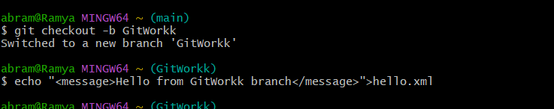

**Add hello.xml in GitWork**

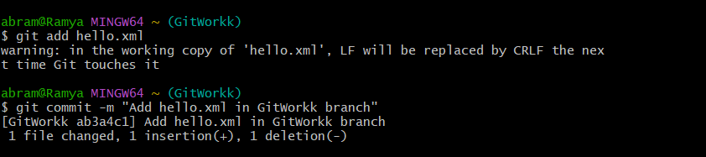

**Add a different hello.xml in main**

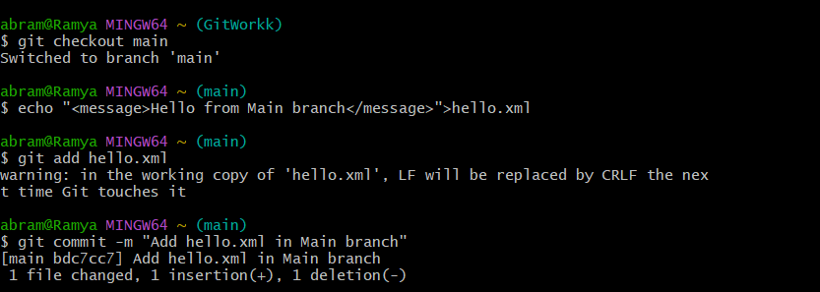

**Observe commit log**

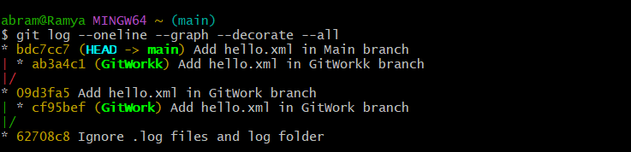

**Check differences between branches**

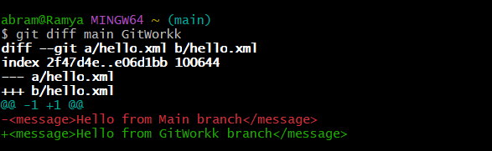

**Merge GitWork into main**

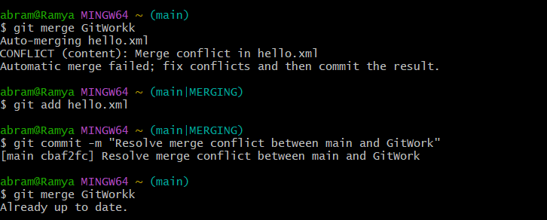

**Update .gitignore to ignore backup files**

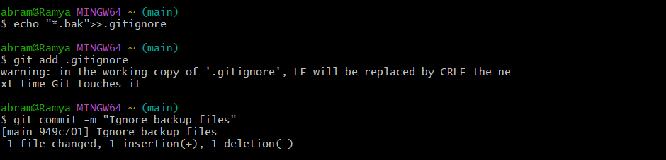

**Delete GitWork branch**

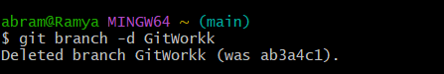

**View final commit history**

